FOOD AND COOKING
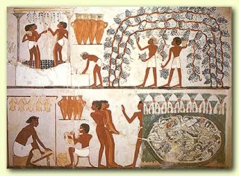
http://egy-king.blogspot.com.au/2012/09/ancient-egypt-food.html
FOOD
The Ancient Egyptians seldom went short of food. The fertile soil of the Nile Valley produced good crops of wheat and barley and enabled the Egyptian farmers to grow a wide variety of fruit and vegetables. Beef cattle, flocks of geese,
There are many tomb paintings which show men at work growing and gathering the plentiful supplies of food. If you look at the picture at the top of the page you can see grapes being gathered and trodden or stomped into wine which was stored in the tall conical jars.
The wildfowl were netted in a bed of papyrus reeds and the picture shows the birds being split, cleaned and hung out in the sun to dry in order to preserve them.

CROSSWORD: If you fill in the blanks correctly, 8 down will tell you what the Nile soil was like.
- Meat eaten by the Egyptians
- Made in clay moulds
- A popular Egyptian drink
- Charcoal was fanned to give more of this
- Drink made from trodden grapes
- Wild ones were netted on the Nile
- Used to sweeten food in Ancient Egypt

The tall jars in the picture probably contained salt. This was used to preserve both wildfowl and fish which would otherwise have rotted very quickly in the hot climate.
COOKING
The Egyptians did not use coal and so most of their cooking was done over charcoal fires. When meat was being roasted, like the goose in the picture, the charcoal was constantly fanned so that it would give off as much heat as possible.
Meat was also eaten boiled and was either served with boiled vegetables or raw vegetables which had been chopped and then dressed with oil and salt rather like a salad. Bread was baked in clay moulds which were first heated in a fire and then filled with dough. The heat from the mould turned the dough into loaves.
The most popular drink in Ancient Egypt was beer which was made by placing pieces of partly baked bread into a mixture of water and date juice. When this had fermented it produced a strong, sweet beer. The Ancient Egyptians were very fond of sweet things and they kept large numbers of bees to provide honey for sweetening their food.

8
1
2
3
4
5
6
7

